Julington Creek Elementary School
Supply List 2024-2025
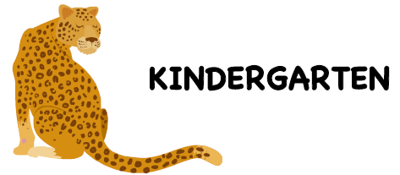
 | Item Description | Qty
1. | My First Ticonderoga pencils (thick pencils) | 2
2. | #2 yellow Ticonderoga pre-sharpened pencil | 1 pk
3. | Large/Jumbo Elmer's glue stick | 4
4. | Blunt 5" Fiskar Scissors | 1
5. | Anti-bacterial hand wipes (canister) | 2 pks
6. | Clorox wipes (canister) | 2 pks
7. | Plastic pencil/supply box – size 8x5x2 (no lock/key or zipper) | 1
8. | 24ct box Crayola crayons | 5
9. | Kleenex Tissue | 1
10. | Primary marble composition (top half blank/bottom lines) | 2
11. | 8 ct. washable, thick Crayola classic markers (Boys) | 1
12. | Brown or clear Band-Aids (Girls) | 1 box
13. | Plastic 2-pocket folder with 3-prongs | 1
14. | Ream of white cardstock | 1
15. | Ream of white copy paper | 1
16. | Storage Ziploc bags- sandwich (Girls) | 1
17. | Storage Ziploc bags – quart (Girls) | 1
18. | Storage Ziploc bags – snack (Boys) | 1
19. | Storage Ziploc bags- gallon (Boys) | 1
20. | SKINNY Expo dry-erase markers (Girls) | 1 pk
21. | Black EXPO dry-erase markers (Boys) | 1 pk
22. | Pink pearl eraser | 1

No rolling backpacks please.

